Hackathon Project Phases Template

Project Title: Gemini Landmark Description App Enhancing Tourists Experiences with AI

Team Name: AI-INNOVATORS
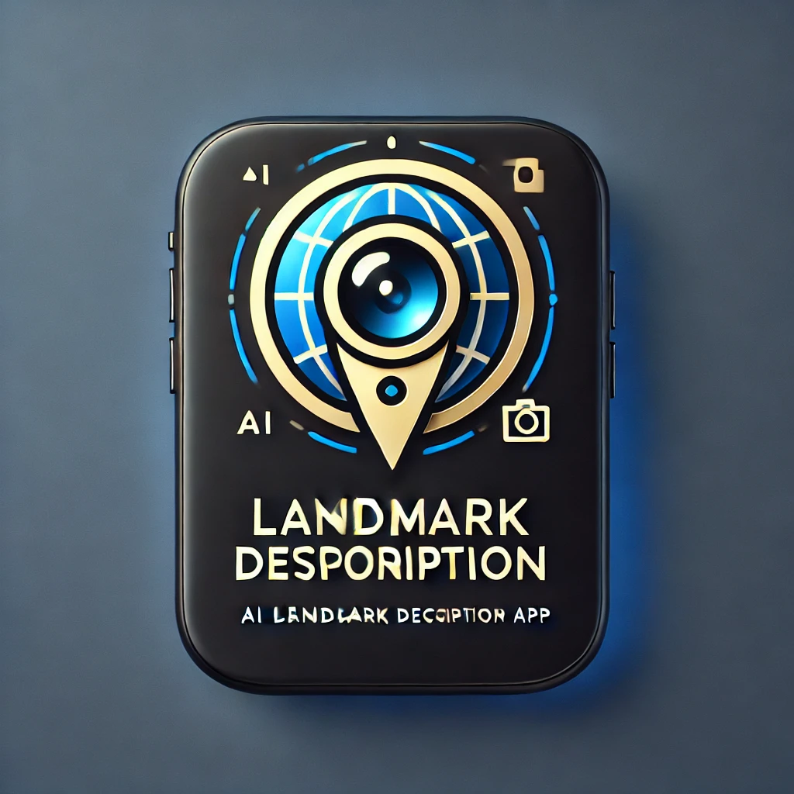

Team Members:
- D. Chaitanya Sai Ganesh(23JR1A0559)
- G. Navadeep(23JR1A0564)
- N. Bala Aditya(23JR1A0541)
- Ch. Rajasekhar Reddy(24JR5A0506)
- D. Venkata Charan Teja(23JR1A0557)

Phase-1: Brainstorming & Ideation

Objective:
The Gemini Landmark Description App aims to enhance tourist experiences by leveraging AI-powered descriptions to provide immersive, informative, and personalized insights into historical landmarks, cultural sites, and attractions worldwide.

Key Points:
- Problem Statement:
  - AI-Powered Landmark Insights – Users can upload an image and input a prompt to receive AI-generated descriptions.

  - Comprehensive Information – Covers historical significance, architectural details, and interesting facts.

  - Enhancing Tourist Experiences – Ideal for travelers, tour guides, and history enthusiasts.

  - Global Cultural Connection – Provides knowledge about landmarks worldwide.

  - Multilingual Support – Enables access to descriptions in multiple languages.

  - Accessibility Features – Ensures inclusivity for all users, including those with disabilities.

  - Instant & Convenient – Quick access to detailed information anytime, anywhere.

- Proposed Solution:
  - An AI-powered application using Gemini Flash to provide real-time vehicle specifications, reviews, and comparisons.
  - The app offers maintenance tips and eco-friendly vehicle insights based on user preferences.
- Target Users:
  - Vehicle buyers looking for specifications and comparisons.
  - Vehicle owners needing seasonal maintenance tips.
  - Eco-conscious consumers searching for hybrid and electric vehicle options.
- Expected Outcome:

  - A functional AI-powered vehicle information app that provides insights based on real-time data and user queries.

Phase-2: Requirement Analysis

Objective:
Define the technical and functional requirements for the AutoSage App.

Key Points:
- User Requirements | - - Target Audience: Tourists, locals, varying tech literacy

- - Easy to Use: Intuitive design, minimal learning curve

- - Personalization: Tailored content based on preferences (language, interests)

- - Offline Functionality: Download maps and descriptions in advance

- - Multi-language Support: To cater to international tourists

- Functional Requirements | - - AI-Powered Landmark Descriptions: Real-time, dynamic descriptions based on user input or images

- - Location-based Services: GPS integration to suggest nearby landmarks

- - Interactive Maps: Detailed maps with landmark info, AR integration for immersive experience

- - Voice Assistance: Voice-controlled interaction for hands-free usage

- - Augmented Reality: Overlay information on landmarks via phone camera

- - Tour Recommendations: Personalized suggestions based on preferences

- - Itinerary Management: Create, modify, share custom itineraries

- - Feedback and Ratings: Allow users to rate and review landmarks

- Non-Functional Requirements | - - Scalability: Ability to add more landmarks, regions, and features

- - Performance: Quick load times and efficient data processing

- - Security: Protect user data (location, preferences)

- - Reliability: App stability with minimal downtime

- - Accessibility: Features for users with disabilities (voice control, contrast modes)

- System Requirements | - - Platform Support: Android and iOS availability

- - Third-Party Integrations: Maps, weather, transport info, etc.

- - AI Models: Use AI for landmark recognition and context-aware descriptions

- - Backend Services: Cloud backend for data storage and processing

- Data Requirements | - - Landmark Data: Accurate, up-to-date information on landmarks (history, images, significance)

- - User Data: Preferences, travel history, and feedback

- - Real-time Data: Weather, crowd info, live events

- AI-Specific Requirements | - - Training Data: Relevant datasets for AI model training (images, user interactions, landmark info)

- - AI Interpretation: AI to interpret text and voice queries about landmarks

- - Continuous Learning: AI improvement based on user interaction

- Legal & Ethical Considerations | Copyright Compliance: Respect copyright laws for content usage

- - Data Privacy: Compliance with regulations like GDPR

- - AI Bias: Address and mitigate biases in AI models

- Monetization Strategy | - - In-App Purchases: Premium features, ad-free options, exclusive content

- - Advertising: Relevant ads for local businesses (hotels, restaurants)

- - Partnerships: Collaborations with tourism boards or local attractions

- Testing & Validation | - - User Acceptance Testing (UAT): Real-world testing with tourists for feedback

- - Continuous Updates: Ongoing maintenance and updates to improve app functionality and features

Phase-3: Project Design

Objective:
Develop the architecture and user flow of the application.
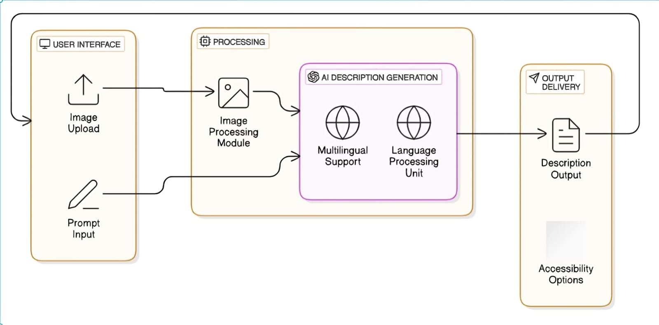

Key Points:
- System Architecture:
  - User enters input as image
  - Query is processed using Google collab.
  - AI model fetches and processes the data.
  - The frontend displays location map,sign up and description space.
- User Flow:
  - Step 1: User uploads an image (e.g., “any place or destination”).
  - Step 2: The backend calls the google collab to retrieve landmark description.
  - Step 3: The app processes the data and displays results in an easy-to-read format.
- UI/UX Considerations:
  - Minimalist, user-friendly interface for seamless navigation.
  - Filters for price, mileage, and features.
  - Dark & light mode for better user experience.

Phase-4: Project Planning (Agile Methodologies)

Objective:
Break down development tasks for efficient completion.
Sprint | Task | Priority | Duration | Deadline | Assigned To | Dependencies | Expected Outcome
Sprint 1 | Environment Setup & API Integration | 🔴 High | 6 hours (Day 1) | End of Day 1 | Rajesh | Google API Key, Python, Streamlit setup | API connection established & working
Sprint 1 | Frontend UI Development | Medium | 1 hour (Day 1) | End of Day 1 | sandesh | API response format finalized | Basic UI with input fields
Sprint 2 | Search & Comparison | 🔴 High | 3 hours (Day 2) | Mid-Day 2 | Sai kumar | API response, UI elements ready | Search functionality with filters
Sprint 2 | Error Handling & Debugging | 🔴 High | 4 hours (Day 2) | Mid-Day 2 | Sai krishna and sai kumar | API logs, UI inputs | Improved API stability
Sprint 3 | Testing & UI Enhancements | 🟡 Medium | 1.5 hours (Day 2) | Mid-Day 2 | Sai krishna | API response, UI layout completed | Responsive UI, better user experience
Sprint 3 | Final Presentation & Deployment | 🟢 Low | 1 hour (Day 2) | End of Day 2 | Entire Team | Working prototype | Demo-ready project

Sprint Planning with Priorities

Sprint 1 – Setup & Integration (Day 1)
(🔴 High Priority) Set up the environment & install dependencies.
(🔴 High Priority) Integrate Google Gemini API.
(🟡 Medium Priority) Build a basic UI with input fields.

Sprint 2 – Core Features & Debugging (Day 2)
(🔴 High Priority) Implement search & comparison functionalities.
(🔴 High Priority) Debug API issues & handle errors in queries.

Sprint 3 – Testing, Enhancements & Submission (Day 2)
(🟡 Medium Priority) Test API responses, refine UI, & fix UI bugs.
(🟢 Low Priority) Final demo preparation & deployment.

Phase-5: Project Development

Objective:
Implement core features of the AutoSage App.

Key Points:
- Technology Stack Used:
  - Frontend: 10Web
  - Backend: google collab
  - Programming Language: Python
- Development Process:
  - Implement API key authentication and Gemini API integration.
  - Develop landmark locaters and maintenance tips logic.
  - Optimize search queries for performance and relevance.
- Challenges & Fixes:
  - Challenge: Delayed API response times.
Fix: Implement caching to store frequently queried results.
  - Challenge: Limited API calls per minute.
Fix: Optimize queries to fetch only necessary data.

Phase-6: Functional & Performance Testing

Objective:
Ensure that the AutoSage App works as expected.
Test Case ID | Category | Test Scenario | Expected Outcome | Status | Tester
TC-001 | Functional Testing | Query "Best budget cars under ₹10 lakh" | Relevant budget cars should be displayed. | ✅ Passed | Tester 1
TC-002 | Functional Testing | Query "Motorcycle maintenance tips for winter" | Seasonal tips should be provided. | ✅ Passed | Tester 2
TC-003 | Performance Testing | API response time under 500ms | API should return results quickly. | ⚠ Needs Optimization | Tester 3
TC-004 | Bug Fixes & Improvements | Fixed incorrect API responses. | Data accuracy should be improved. | ✅ Fixed | Developer
TC-005 | Final Validation | Ensure UI is responsive across devices. | UI should work on mobile & desktop. | ❌ Failed - UI broken on mobile | Tester 2
TC-006 | Deployment Testing | Host the app using Streamlit Sharing | App should be accessible online. | 🚀 Deployed | DevOps

Final Submission
- Project Report Based on the templates
- Demo Video (2 Minutes)
- GitHub/Code Repository Link
- Presentation

